

**Experiment No:07**

**Aim:** Prepare a timeline Chart for our project

**Tools:** Microsoft Excel

**Theory:**

A timeline chart is a visual rendition of a series of events. It can be created as a chart or a graph. Timeline charts can be created for anything that occurred over a period of time. You might see a timeline chart for World War II or major events of the 20th century. As a business owner, you might have a timeline chart of new product development or a sales campaign.

A timeline chart makes it easier to conceptualize a process or a sequence of events. It can make it easier for you to understand the intricacies of a project or why something seems to take so long to accomplish

* **Different Kinds of Timelines**

**Gantt Chart:**

A Gantt chart is a fantastic organizational tool and most commonly used for project management. It will feature variously sized bars spread across a timeline, each bar representing the start date, duration and end date of an activity. Once studying the chart, you will be able to see the whole sum of the projects within its time frame. Where do activities overlap? How long will the whole project take? Remember our Gantt charts can be easily updated if your running off schedule or god forbid ahead of time! Here is an example of a Gantt Chart in the form of a housing refurbishment schedule.

**Standard Timeline Chart:**

What’s a timeline without a nice simple one!? Rather than bars graphically showing event lengths like in a Gantt Chart, a standard timeline chart shows pinpointed single events with accompanying text and/or imagery. These are classically found in History Classrooms and Museums but actually have a wind range of uses. Here is the timeline of the short but beautiful life of a Monarch Butterfly.

**Time Series Graph:**

A time series graph uses an X and Y axis to illustrate a quantity/measurement change throughout time. In most cases the horizontal axis (X) of the chart is used to mark increments in time and the vertical axis (Y) pinpoints values of the variable which is being measured. When the values are connected in chronological order by a line, it creates a series of peaks and troughs. These peaks and troughs can tell a story of progression or decline and are useful in visualizing data to create reports and forecasts. They are quite often created from financial and scientific data.

* **How to create and use timeline charts for project management**

**Step 1:** Create your project.

**Step 2:** Add tasks to your project

**Step 3:** Schedule your tasks

**Step 4:** Create task dependencies

**Timeline Chart for our project**

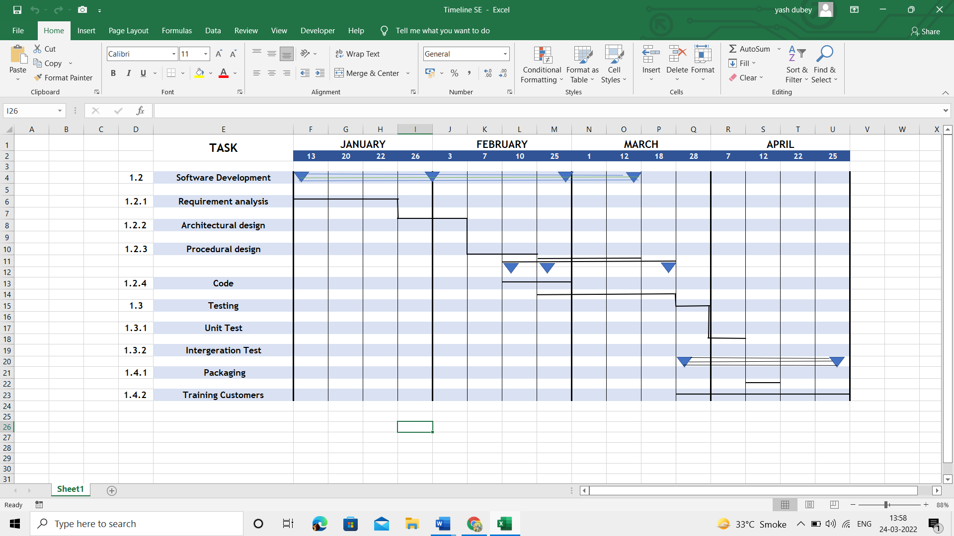

**Conclusion:** Thus, we have successfully prepared a Timeline Chart for Bank Management System System.

For Faculty Use

|  |  |  |  |  |
| --- | --- | --- | --- | --- |
| **CorrectionParameters** | **FormativeAssessment[40%]** | **Timely completionofPractical[40%]** | **Attendance /LearningAttitude[20%]** |  |
| **MarksObtained** |  |  |  |